NEW PRODUCT • MAY 2026
3500 Pent Bin Store
Secure, compact commercial bin storage for two 1,100-litre bins.
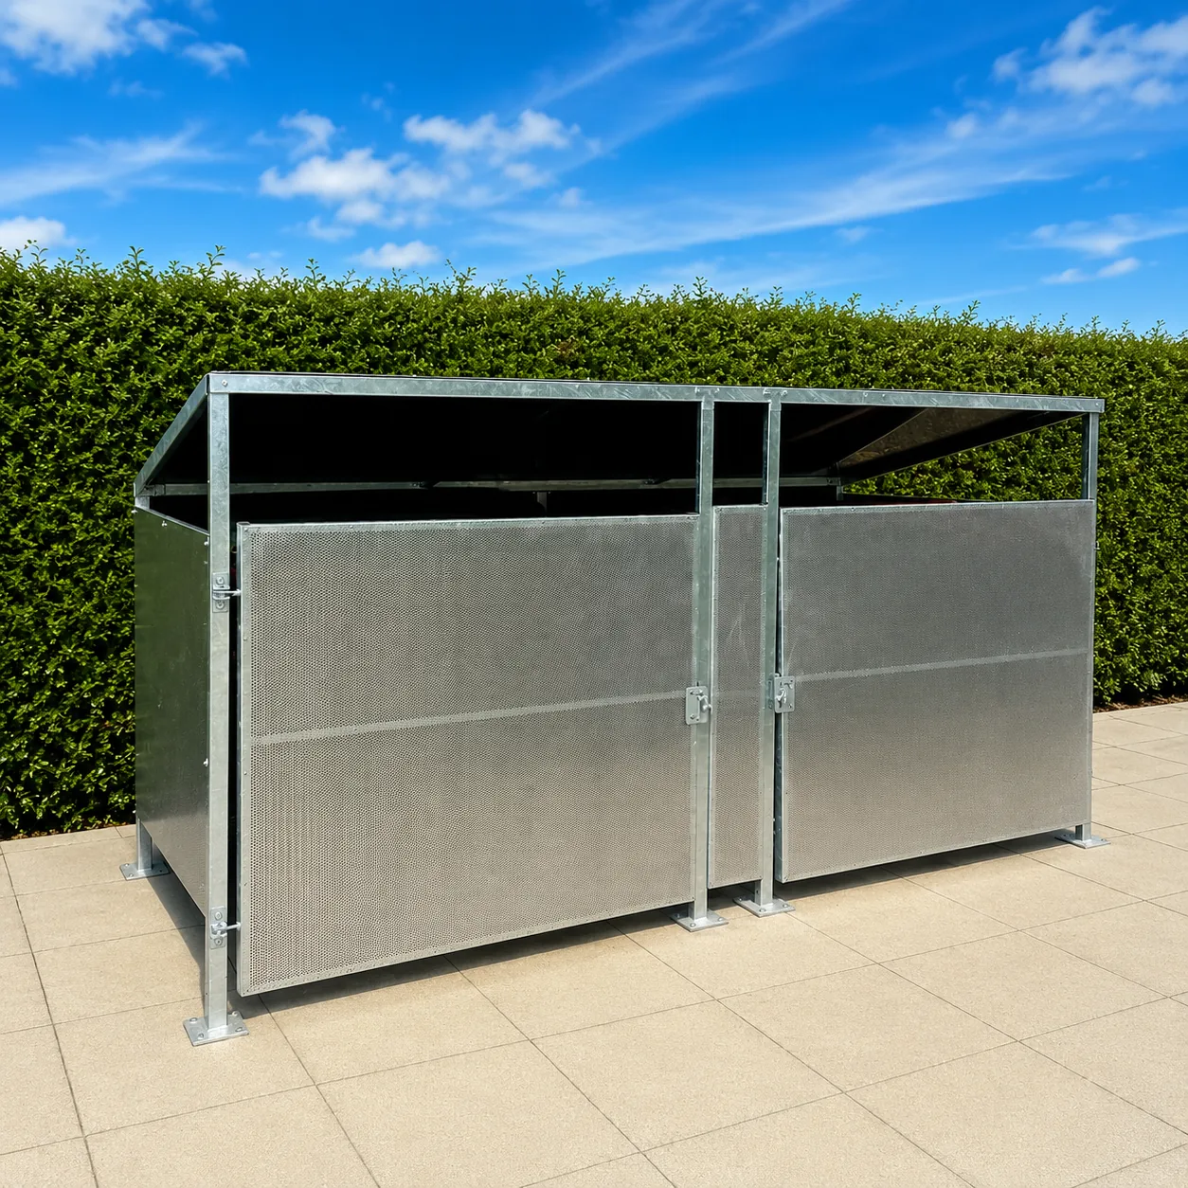 | BUILT FOR  Retail  Hospitality  Leisure  HMO & commercial sites  A robust metal alternative to timber bin enclosures.
Designed and manufactured in the UK, the 3500 Pent Bin Store combines a hot-dip galvanised steel frame, perforated galvanised steel gates and durable panel cladding to keep commercial waste areas tidy, secure and presentable.
CAPACITY  2 × 1,100 L  commercial bins | UNIT SIZE  3500 × 1550 mm x 2100 mm  1800 mm high to front | LEAD TIME  14 days  standard lead time
CONSTRUCTION  Galvanised steel  50 × 25 mm RHS frame | ASSEMBLY  Flat pack  2 people • approx. 2–3 hours | DELIVERY  FREE  UK mainland carriage
PRODUCT OVERVIEW
Designed to Improve the Appearance of Waste Areas
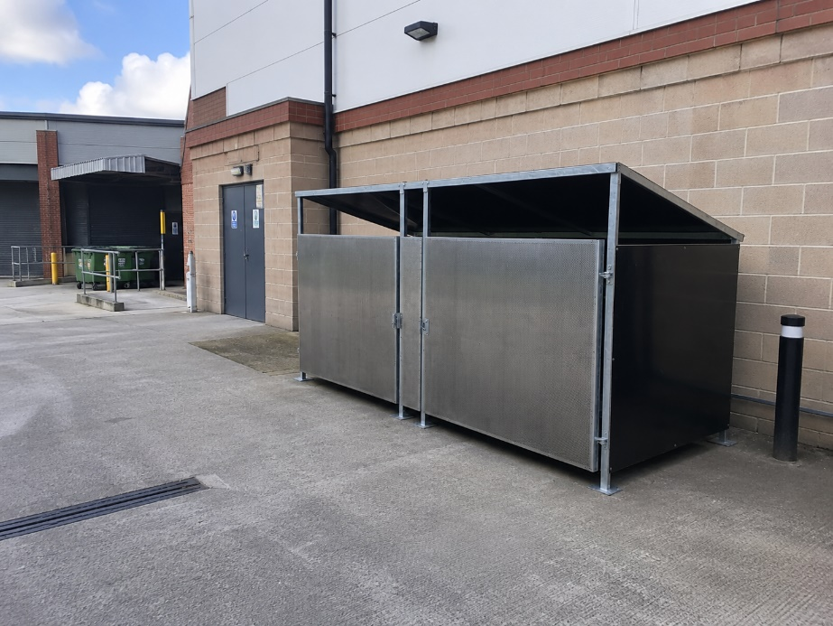  Installed against a commercial building | WHY CHOOSE IT  - Purpose-built for two 1,100-litre commercial bins  - Compact 3500 × 1550 mm body size  - Perforated galvanised steel gates for strength and ventilation  - Aluminium composite roof, back and side panels as standard  - Optional full galvanised metal panel construction  - Suitable for retail, hospitality, leisure and HMO premises
SITE EXAMPLE
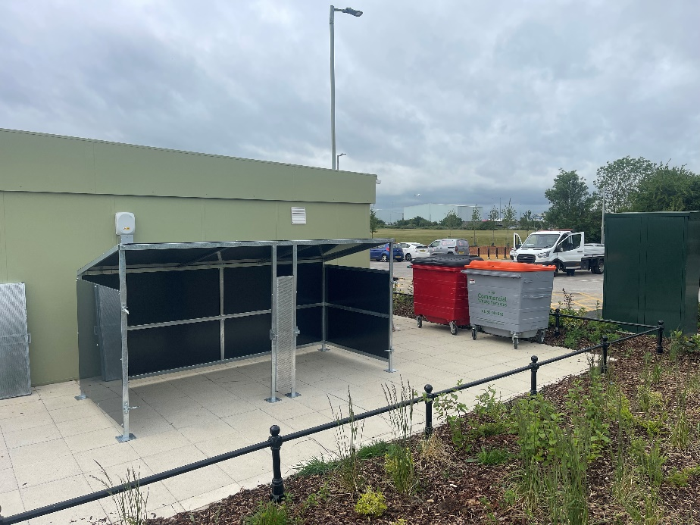  During installation at Wigmore Valley Park, adjacent to Luton Airport | SMALL FOOTPRINT  Approx. 8–9 m²  Allowing for the unit and gate opening space, making it suitable for tighter service areas.  UK-made construction helps turn a traditionally overlooked waste area into a cleaner, more professional-looking space.
COMMERCIAL INFORMATION
Options & Pricing
3500 × 1550 mm Pent Bin Store options
Option | Product code |  | Net | VAT | Inc. VAT
Open • no roof | USP/PENT3500/1550/ONR |  | £1,280.00 | £256.00 | £1,536.00
Open • with roof | USP/PENT3500/1550/OWR |  | £1,430.00 | £286.00 | £1,716.00
Gated • no roof | USP/PENT3500/1550/GNR |  | £1,908.00 | £381.60 | £2,289.60
Gated • with roof | USP/PENT3500/1550/GWR |  | £2,058.00 | £411.60 | £2,469.60
LEAD TIME  14 DAYS  Standard lead time |  | CARRIAGE  FREE  UK mainland delivery |  | OTHER DESTINATIONS  CALL US  For a carriage quote
PANEL OPTIONS
Standard specification uses aluminium composite panels to the roof, back and sides. The unit is also available with galvanised metal panels to the roof, sides and back for an essentially all-steel assembly.
AVAILABLE COLOURS
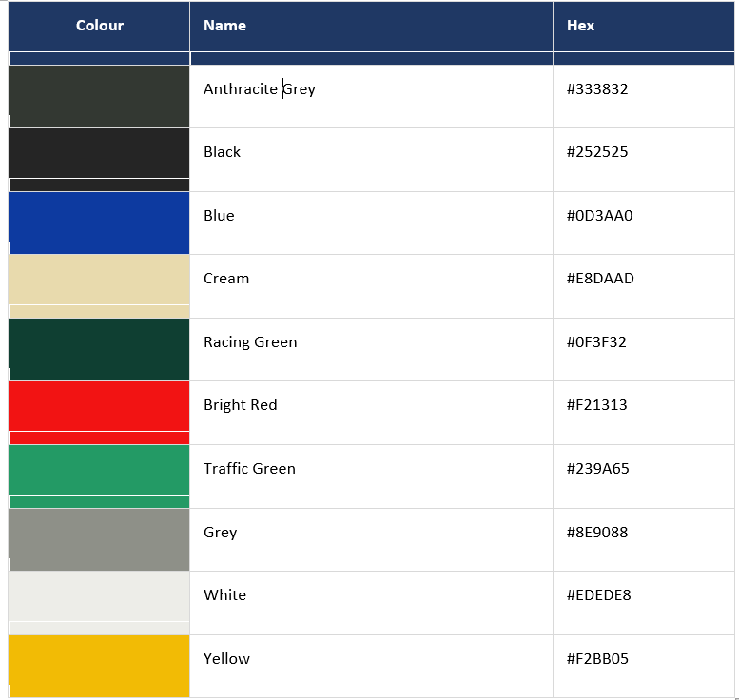
CONSTRUCTION & CAPACITY
Built for Long Service Life
CORE SPECIFICATION  FRAME  50 × 25 mm RHS steel  FINISH  Hot-dip galvanised to BS EN ISO 1461:2022  BASE PLATES  6 mm galvanised steel, four anchor holes per plate  PANELS  Skybond 3 mm aluminium composite  GATES  Perforated galvanised steel sheet  ROOF  Optional fully enclosed weather-resistant roof  VENTILATION  Vents at the top of side panels | 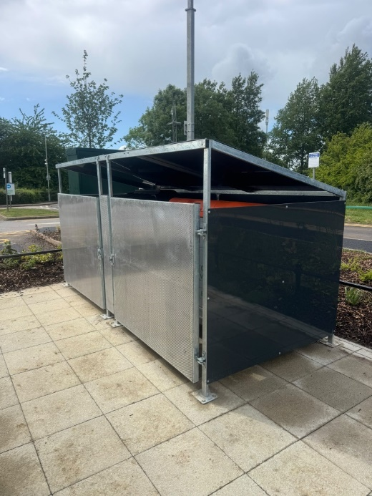  Gated pent bin store installation
CAPACITY
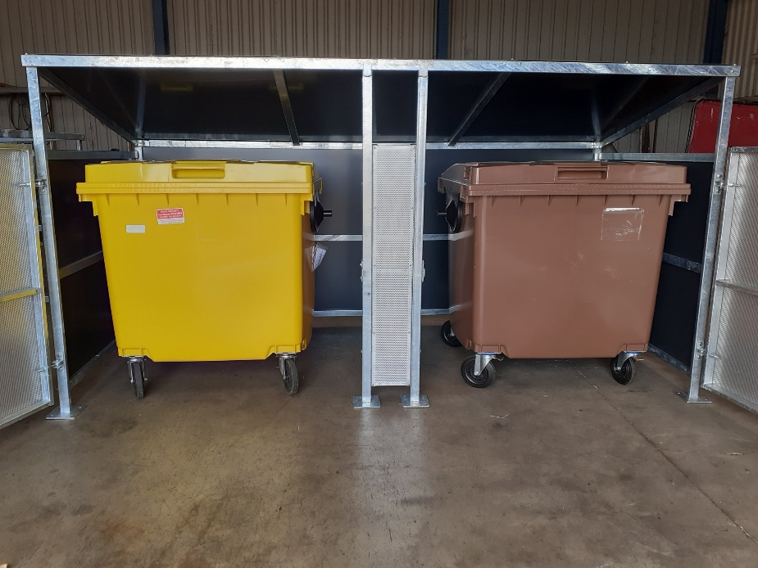  Internal capacity shown with two commercial bins | 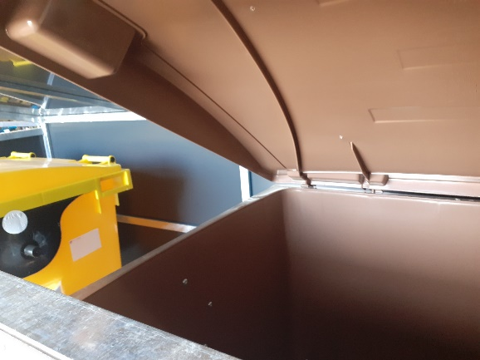  Roof and panel detail
Supplied as a flat-pack product for self-assembly. The original specification indicates assembly by two operatives should take approximately 2–3 hours.
DRAWINGS & ORDERING
Technical Dimensions
FRONT ELEVATION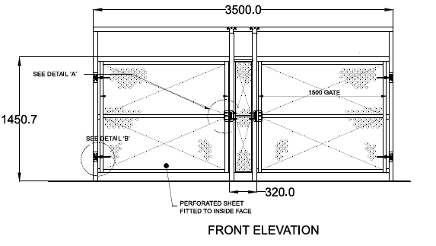 | END ELEVATION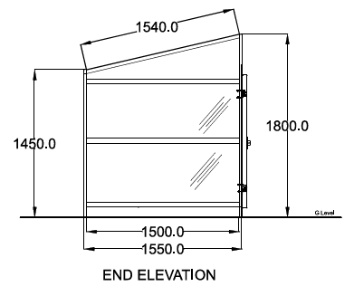
PLAN
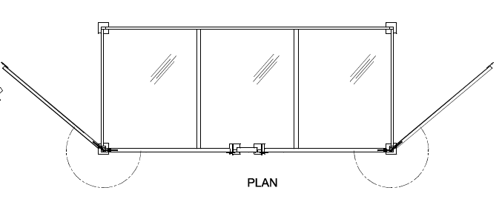
READY TO ORDER?  Tell us the delivery address, postcode and how soon you need the unit.  0191 534 3211 • sales@urbanfab.com | ONLINE  www.urbanfab.com
Shield Green Trading Company Ltd • VAT No. 270051639 • Company Registration No. 10785682

